# SWI Observation Extractor

Richard B. Winston

SWI Observation Extractor version 1.0 is used to read an output file of the SWI package in MODFLOW-2005 (Harbaugh, 2005) or MODFLOW-NWT (Niswonger and others, 2011) and generate a simpler file that can readily be used in automated parameter calibration. It does this by interpolating among several simulated values saved by the SWI package. In the SWI package, the user can specify cells at which simulated values will be saved at each time step. The file containing the simulated values can be either an ASCII text file or a binary file. SWI Observation Extractor can handle either one. When parameter estimation, is performed, it is convenient to be able to have a smaller file that contains little beyond the simulated value at the specific times and locations where an observation was made.

SWI Observation Extractor allows the user to specify several of the observation locations and provide a weight for each one. These weights are used to calculate simulated values at the observation location. If an observation time does not correspond to a time in the output file generated by the SWI package, SWI Observation Extractor will interpolate linearly between values calculated for times before and after the observation time.

It is up to the user how to assign the weights to the cells surrounding the observations. One way would be to use a finite element basis function. This is the method that is used to interpolate observed heads in MODFLOW-2000 (Hill and others, 2000) from the values calculated at the cell centers surrounding an observation location. As will be described later, a modified version of ModelMuse (Winston, 2009, 2014) uses this approach in assigning weights.

The output file generated by the SWI package lists the simulation time followed by the value for each zeta surface for each observation cell. Each observation cell is given a name by the modeler in the SWI input file. The zeta surface number is indicated by a three digit value appended to the observation name. If the SWI package generates the output file as an ASCII text file, these modified names are listed as the first line of the file. In binary files, labels are not included but the values are saved in the same order as they would be in a text output file. SWI Observation Extractor identifies observations in the SWI output file based on the order on which a particular observation cell appears in the list of observation cells and the zeta surface number of the observation. In addition, it needs to know the total number of observation locations and the number of zeta surfaces in the model. From these, it can determine the positions of the simulated values for any particular observation cell and zeta surface in the output file. If the output file is a text file, it will also compare the observation name and zeta surface with the label printed in the output file. This serves to check that the desired observation value has been identified correctly. With binary files, it also needs to know whether the values have been saved in single-precision (32 bit) or double precision (64 bit) so that the values can be read correctly.

## Input format

The input for SWI Observation Extractor is a text file. The name of the input file can be included in the command line when starting the program. If it is not included on the command line, the program will prompt the user for the name of the input file. If the name of the input file contains spaces, the name should be enclosed in double-quotes.

The input file uses a “tag [value [value]]” format for its input in which each line starts with a tag followed (usually) by a one or more values associated with that tag. Tags are not case sensitive. Blank lines are allowed. If a line begins with the “#” character it is ignored. Such lines can be used to insert comments into the input file. Tags may be preceded by space characters.

The input for SWI Observation Extractor is divided into two blocks: “FILE_OPTIONS” and “OBSERVATIONS” The FILE_OPTIONS block must appear first.

### The FILE_OPTIONS Block

The FILE_OPTIONS block starts with “BEGIN FILE_OPTIONS” and ends with “END FILE_OPTIONS”. The FILE_OPTIONS block must include the following tags. The tags may appear in any order but it is recommended that the OUTPUT_FILE tag appear first.

* OUTPUT_FILE <filename>
* SWI_OBS_FILE <filename>
* SWI_OBS_FORMAT (ASCII | Binary single | Binary double)
* TOTAL_NUMBER_OF_OBSERVATIONS <number>
* NUMBER_OF_ZETA_SURFACES <number>
* [INSTRUCTION_FILE_FORMAT (UCODE | PEST)]
* [DATA_TO_WRITE (VALUES | INSTRUCTIONS)]

#### OUTPUT_FILE

The OUTPUT_FILE tag is followed by the name of the output file to be generated by SWI Observation Extractor. If the file name contains spaces, it should be enclosed in double quotes.

#### SWI_OBS_FILE

The SWI_OBS_FILE tag is followed by the name of the file of observations generated by the SWI package. If the file name contains spaces, it should be enclosed in double quotes.

#### SWI_OBS_FORMAT

The SWI_OBS_FORMAT tag is used to indicate whether the file generated by the SWI package is a binary file or a text file. If the file is a binary file, it also used to specify whether the file has single precision or double precision numbers. SWI_OBS_FORMAT is followed by “ASCII” to indicate that the SWI output file is a text file. SWI_OBS_FORMAT is followed by to values for a binary file. “Binary Single” indicates a single precision SWI output file. “Binary Double” indicates a single precision SWI output file. None of the values for the SWI_OBS_FORMAT tag are case sensitive.

#### TOTAL_NUMBER_OF_OBSERVATIONS

The TOTAL_NUMBER_OF_OBSERVATIONS tag indicates the total number of SWI observation cells in the SWI package input. Some or all of these observation cells may be used in interpolating to observation locations.

#### NUMBER_OF_ZETA_SURFACES

The NUMBER_OF_ZETA_SURFACES tag is followed by the number of zeta surfaces in the model.

#### INSTRUCTION_FILE_FORMAT

INSTRUCTION_FILE_FORMAT determines the format used for the instruction file. It must be followed by either “UCODE” or “PEST”. The instruction file will be written differently depending on which is specified. INSTRUCTION_FILE_FORMAT is optional. If not specified, the UCODE format will be used.

#### DATA_TO_WRITE

DATA_TO_WRITE determines whether observed values are written to the output file and whether an instruction file is written. DATA_TO_WRITE must be followed by either “VALUES” or “INSTRUCTIONS”. DATA_TO_WRITE is optional. If not specified both observed values and an instruction file will be written.

### The OBSERVATIONS Block

The OBSERVATIONS Block begins with “BEGIN OBSERVATIONS” and ends with “END OBSERVATIONS”. Within the OBSERVATIONS are a series of OBSERVATION blocks each of which defines a single observation. Each separate observation blocks begins with “BEGIN_OBSERVATION” and ends with “END_OBSERVATION”. Note that there is an underscore connecting BEGIN or END with OBSERVATION and that OBSERVATION is singular rather than plural.

The following tags are included in the OBSERVATION block

* NAME <observation_name>
* TIME <elapsed_time>
* ZETA_SURFACE_NUMBER <zeta_number>
* OBSERVED_VALUE <value>
* SWI_OBSERVATION <obs_position, weight, label>

#### NAME

The NAME tag is followed by the name of the zeta surface observation. This is not the same as the name of the observation cell in the SWI package input and output.

#### TIME

The Time tag is followed by the time of the zeta surface observation measured from the beginning of the first stress period.

#### ZETA_SURFACE_NUMBER

The ZETA_SURFACE_NUMBER tag is followed by the number of the zeta surface to which the observation applies.

#### OBSERVED_VALUE

The OBSERVED_VALUE tag is followed by the observed value of the zeta surface.

#### SWI_OBSERVATION

The SWI_OBSERVATION tag is used to identify the observation cells in the SWI output file that surround the observation location and assign a weight to each observation cell. The first value is an integer that identifies the position of the observation cell in the list of observation cells in data set 8 of the SWI input file. The second value is the weight assigned to that observation cell. The third value is the name of the observation cell in data set 8 of the SWI input file. The name is optional if the SWI output file is binary but it is required if it is a text file. Multiple copies of the SWI_OBSERVATION tag can be included in a single OBSERVATION block.

### Example Input File

BEGIN FILE_OPTIONS

OUTPUT_FILE "C:\Colab\GWModelTools\ModelMuse\SWI\SWI4_2d_sww.swi_obsi_out"

SWI_OBS_FILE "C:\Colab\GWModelTools\ModelMuse\SWI\SWI4_2d_sww.swi_obs"

SWI_OBS_FORMAT ASCII

TOTAL_NUMBER_OF_OBSERVATIONS 6

NUMBER_OF_ZETA_SURFACES 2

END FILE_OPTIONS

BEGIN OBSERVATIONS

BEGIN_OBSERVATION

NAME P2_120

TIME 7.738000000000E+004

ZETA_SURFACE_NUMBER 1

OBSERVED_VALUE -3.500000000000E+001

SWI_OBSERVATION 1 1.720969078835E-001 Obs_1

SWI_OBSERVATION 2 4.255023243973E-001 Obs_2

SWI_OBSERVATION 3 2.865172054360E-001 Obs_3

SWI_OBSERVATION 4 1.158835622832E-001 Obs_4

END_OBSERVATION

BEGIN_OBSERVATION

NAME P3_180

TIME 8.395000000000E+004

ZETA_SURFACE_NUMBER 1

OBSERVED_VALUE -3.500000000000E+001

SWI_OBSERVATION 1 1.720969078835E-001 Obs_1

SWI_OBSERVATION 2 4.255023243973E-001 Obs_2

SWI_OBSERVATION 3 2.865172054360E-001 Obs_3

SWI_OBSERVATION 4 1.158835622832E-001 Obs_4

END_OBSERVATION

BEGIN_OBSERVATION

NAME P3_min

TIME 7.890000000000E+004

ZETA_SURFACE_NUMBER 1

OBSERVED_VALUE -3.700000000000E+001

SWI_OBSERVATION 1 1.720969078835E-001 Obs_1

SWI_OBSERVATION 2 4.255023243973E-001 Obs_2

SWI_OBSERVATION 3 2.865172054360E-001 Obs_3

SWI_OBSERVATION 4 1.158835622832E-001 Obs_4

END_OBSERVATION

END OBSERVATIONS

## Output File Format

SWI Observation Extractor creates two output files. The first is the main output file defined in the OUTPUT_FILE tag. The second is an “instruction file” that can be used by UCODE (Poeter and others, 2005) or PEST (Doherty, 2019) to extract the observations for use by automated parameter estimation. The instruction file will have the same name as the main output file with “.jif” or “.ins” appended to the end of the name for UCODE and PEST respectively.

The main output file contains the options from the FILE_OPTIONS block and the observation definitions from the OBSERVATIONS block of its input file. Then there is a line with just the text “OBSERVATIONS” followed by a second value that acts as a label for the interpolated simulated observations that follow. These two lines are followed by one line for each observation definition. Each of these lines has the simulated value interpolated from the SWI output file, the observed value copied from the SWI Observation Extractor input file and the observation name copied from the SWI Observation Extractor input file. These values appear in the same order as they do in the SWI Observation Extractor input file.

### Example Main Output File

SWI Observation Interpolator

INPUT OPTIONS

Output File: C:\Colab\GWModelTools\ModelMuse\SWI\SWI4_2d_sww.swi_obsi_out

SWI Observation File: C:\Colab\GWModelTools\ModelMuse\SWI\SWI4_2d_sww.swi_obs

SWI Observation File Format: ASCII

Total number of observations: 6

Total number of zeta surfaces: 2

OBSERVATION DEFINITIONS

"P2_120" 77380 1 -35 # Name, Time, Zeta Surface, Observed Value

1 0.1720969078835 Obs_1 # Observation Number, Fraction, Name

2 0.4255023243973 Obs_2 # Observation Number, Fraction, Name

3 0.286517205436 Obs_3 # Observation Number, Fraction, Name

4 0.1158835622832 Obs_4 # Observation Number, Fraction, Name

"P3_180" 83950 1 -35 # Name, Time, Zeta Surface, Observed Value

1 0.1720969078835 Obs_1 # Observation Number, Fraction, Name

2 0.4255023243973 Obs_2 # Observation Number, Fraction, Name

3 0.286517205436 Obs_3 # Observation Number, Fraction, Name

4 0.1158835622832 Obs_4 # Observation Number, Fraction, Name

"P3_min" 78900 1 -37 # Name, Time, Zeta Surface, Observed Value

1 0.1720969078835 Obs_1 # Observation Number, Fraction, Name

2 0.4255023243973 Obs_2 # Observation Number, Fraction, Name

3 0.286517205436 Obs_3 # Observation Number, Fraction, Name

4 0.1158835622832 Obs_4 # Observation Number, Fraction, Name

OBSERVATIONS

Simulated Value, Observed Value, Name

-33.0461065150981 -35 "P2_120"

-31.9027644531156 -35 "P3_180"

-34.3673296901755 -37 "P3_min"

### Example Instruction File

jif @

StandardFile 28 1 3

P2_120

P3_180

P3_min

## Modifications to ModelMuse for SWI Observation Extractor

Several modifications were made to ModelMuse (Winston, 2009, 2014) to facilitate its use with SWI Observation Extractor. In the MODFLOW Packages and Programs dialog box, a new control was added in which the use specifies the precision that is used in MODFLOW (figure 1). This control is only enabled if the output file for observations is a binary file.

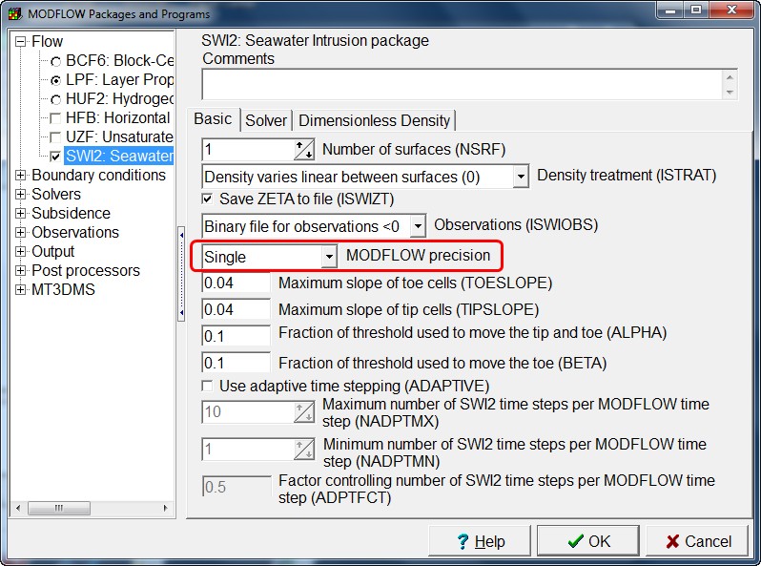

Figure . Screenshot of modification to the MODFLOW Packages and Programs dialog box. The new MODFLOW Precision control is highlighted in red.

The Object Properties dialog box was modified to allow the user to define SWI observations interpolated to the time and location of the observation (figure 2). Objects used to define such observations should be point objects on the top view of the model that intersect a single cell. If a point object extends over several layers only the uppermost cell intersected by the object will be used to define an observation.

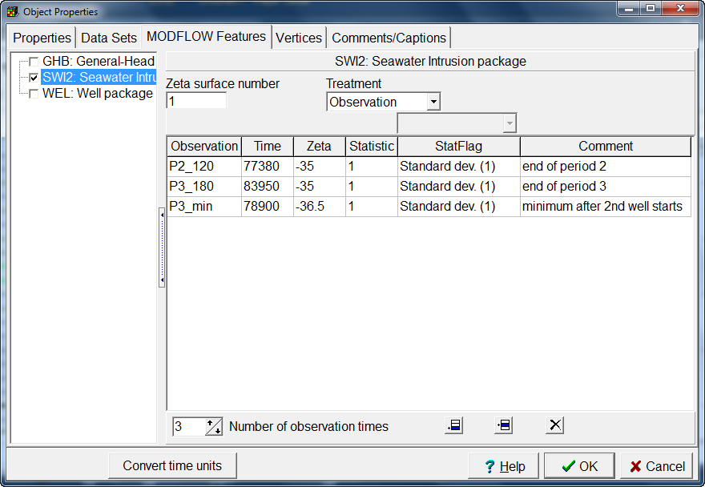

Figure . Screenshot of the modified version of the Object Properties dialog box for use in defining interpolated SWI observations.

When ModelMuse generates the input for a MODFLOW model in which interpolated SWI observations are defined, it will automatically add observation cells to data set 8 of the SWI input file for all the cell centers of active cells surrounding the observation locations. It will also create an input file for SWI Observation Extractor that uses those observation cells to define interpolated observations. If more than one observation cell is included in an interpolated observation, the weights assigned to each cell will be based on linear, triangular, or rectangular finite element basis function in the same way that head observations are interpolated from surrounding cells in MODFLOW.

Three changes have been made to how ModelMuse interacts with ModelMate (Banta, 2011). First, data from interpolated SWI observations can now be transferred between ModelMuse and ModelMate. Second, ModelMuse will create an entry in the ModelMate file linking the main output file generated by SWI Observation Extractor to the corresponding instruction file. Third, ModelMuse now creates a batchfile named “RunModel.bat” that is suitable for use with automated parameter estimation programs and will pass that name to ModelMate as the command to run the model. The batch file will run both MODFLOW and SWI Observation Extractor when interpolated SWI observations are defined.

## Example

A modification of Example 4 from the SWI documentation (Bakker and others, 2013) is used to show how SWI Observation Extractor can be used to help calibrate a model using automated parameter estimation. The two layer model has an island surrounded by the ocean. In the first stress period, recharge on the island creates a freshwater lens beneath the island. In the second stress period, a pumping well is added that extracts water from the freshwater lens causing upconing of saltwater beneath the island. In the third stress period, a well pumping from the salt water zone is added beneath the well pumping from the fresh water zone. This causes the interface between fresh and salt water to decline temporarily before starting to rise again. In the modified model, the well pumping rates are specified with parameters and observations of the zeta surface near the pumping wells are added. The observed zeta values were set to approximately 5 m below the values simulated in the original models. Three observations were used (fig. 3). They were at the ends of the second and third stress period and close to the time when the zeta surface reached a minimum in the third stress period. ModelMate version 1.0.2 (Banta, 2011) and UCODE-2005 version 1.028 (Poeter and others, 2005) were used to calibrate the model. In the calibrated model, the pumping rates of the two wells were each reduced by 16% to 17%. A difference in the position of the zeta surface at the end of the last stress period in the row containing the wells shows that in the calibrated model, the zeta surface was substantially lowered near the well.



Figure 3. Cross section of example model showing the zeta surface of the uncalibrated model in red and the calibrated model n blue.

## Availability

SWI Observation Extractor version 1.0 is available from <https://doi.org/10.5066/F79022ZJ>. The modified version of ModelMuse is available from https://water.usgs.gov/nrp/gwsoftware/ModelMuse/ModelMuse.html.

## References

Bakker, M., Schaars, F., Hughes, J.D., Langevin, C.D., Dausman, A.M., 2013, Documentation of the seawater intrusion (SWI2) package for MODFLOW: U.S. Geological Survey Techniques and Methods, book 6, chap. A46, 47 p., <http://pubs.usgs.gov/tm/6a46/>.

Banta, E.R., 2011, ModelMate—A Graphical User Interface for Model Analysis: U.S. Geological Survey Techniques and Methods, book 6, chap. E4, 31 p.

Doherty, John, 2019. PEST: Model-Independent Parameter Estimation, 7th Edition, Watermark Numerical Computing, 368 p. http://www.pesthomepage.org

Harbaugh, A.W., 2005, MODFLOW-2005, the U.S. Geological Survey modular ground-water model -- the Ground-Water Flow Process: U.S. Geological Survey Techniques and Methods 6-A16, variously p.

Hill, M.C., Banta, E.R., Harbaugh, A.W., and Anderman, E.R., 2000, MODFLOW-2000, the U.S. Geological Survey modular ground-water model -- User guide to the Observation, Sensitivity, and Parameter-Estimation Processes and three post-processing programs: U.S. Geological Survey Open-File Report 00-184, 210 p.

Niswonger, R.G., Panday, Sorab, and Ibaraki, Motomu, 2011, MODFLOW-NWT, A Newton formulation for MODFLOW-2005: U.S. Geological Survey Techniques and Methods 6-A37, 44 p.

Poeter, E.P., Hill, M.C., Banta, E.R., Mehl, Steffen, and Christensen, Steen, 2005, UCODE_2005 and Six Other Computer Codes for Universal Sensitivity Analysis, Calibration, and Uncertainty Evaluation: U.S. Geological Survey Techniques and Methods 6-A11, 283p.

Winston, R.B., 2009, ModelMuse-A graphical user interface for MODFLOW-2005 and PHAST: U.S. Geological Survey Techniques and Methods 6-A29, 52 p.

Winston, R.B., 2014, Modifications made to ModelMuse to add support for the Saturated-Unsaturated Transport model (SUTRA): U.S. Geological Survey Techniques and Methods, book 6, chap. A49, 6 p., http://dx.doi.org/10.3133/tm6a49.